**PROJECT DEVELOPMENT PHASE SPRINT DELIVERY -2**

**TEAM ID**

**: PNT2022TMID26228**

**PROJECT : Analytics for**

**Hospital Health-Care Data**

**DATE : 5 NOV 2022**

**ANALYTICS FOR HOSPITAL HEALTH - CARE DATA**

Divya Darshani.R

Nanditha.v

Vishali.M

Vaidegi.B

**Team ID - PNT2022TMID26228**

Project Development Phase

|  |  |
| --- | --- |
| **Sprint-1:**   * **Data Collection** * **Loading of data** * **Data Preparation** | **Sprint-3:**   * **Dashboard Creation** |
| Sprint-2:   * Data Exploration * Data Visualization | Sprint-4:   * Report Creation * Story Creation |

DATA EXPLORATION

Ward_Type for Ward_Facility_Code:

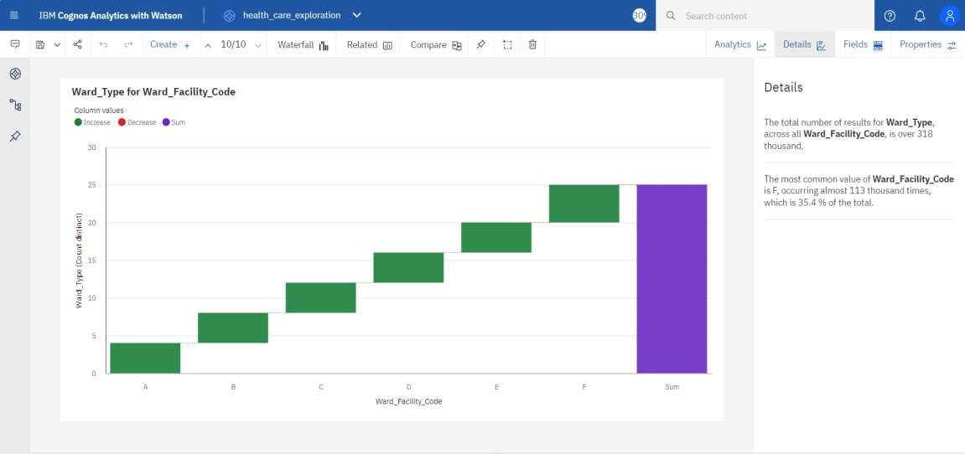

case_id by patient id:

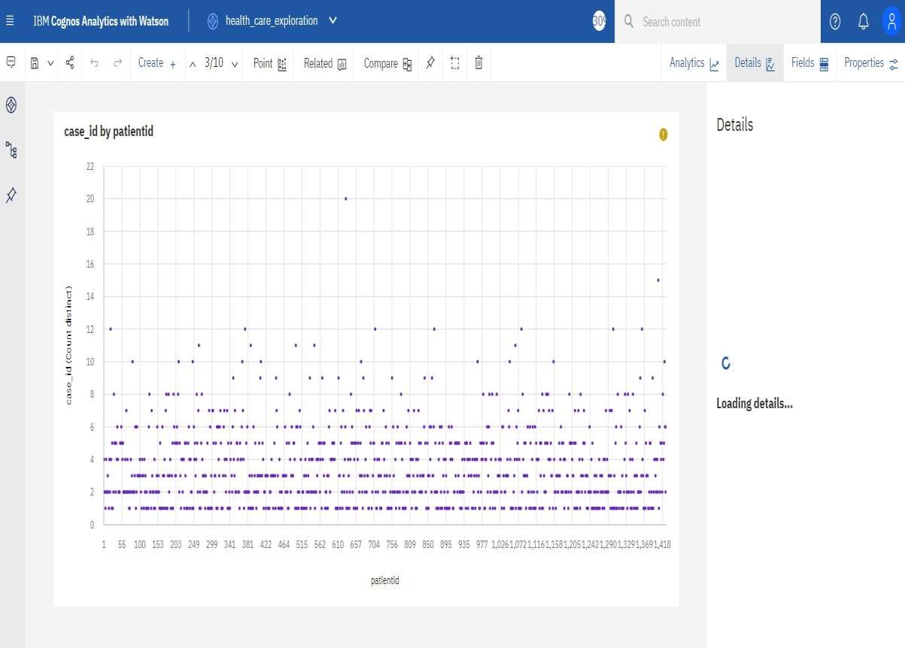

Visitors with Patient by Type of Admission:

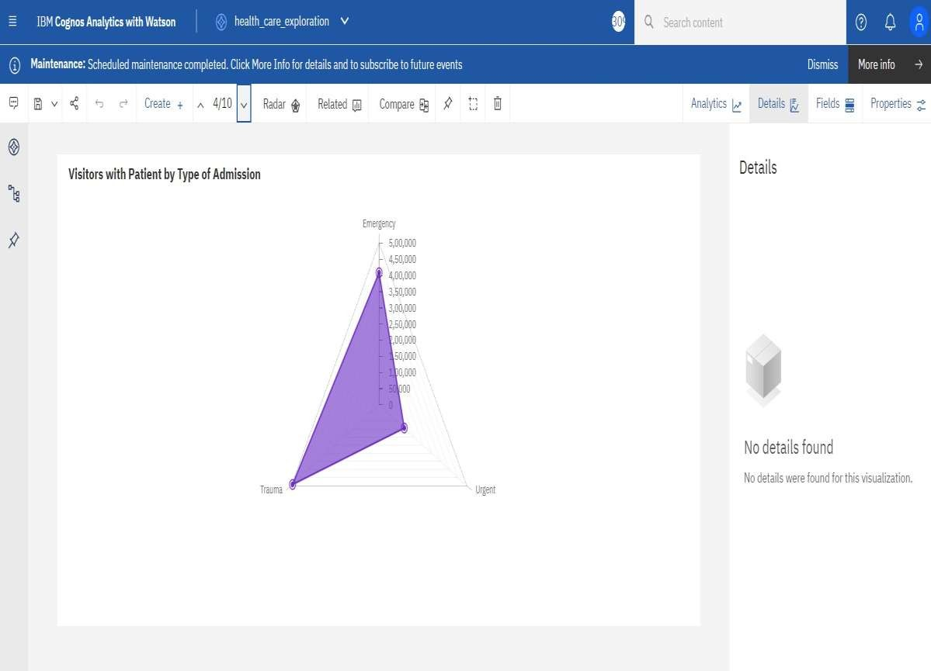

City_Code_Hospital by City_Code_Hospital:

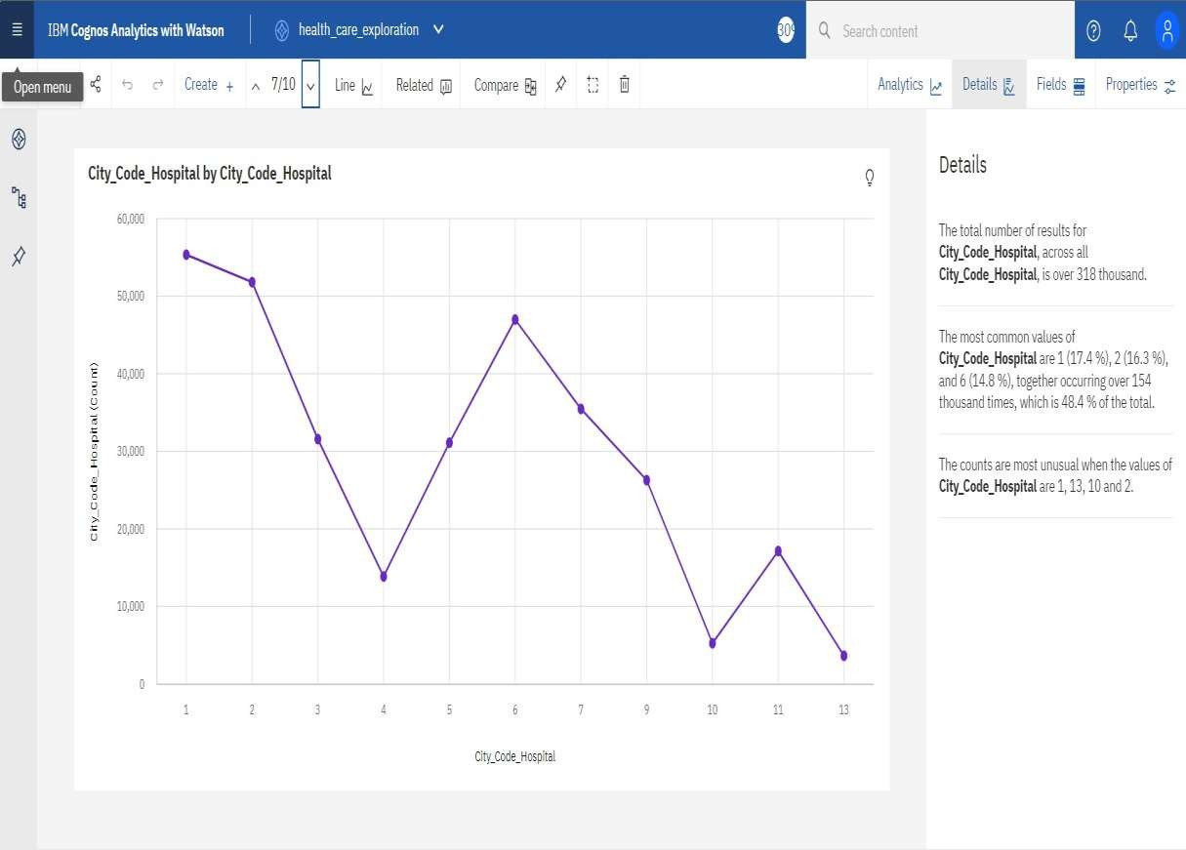

City_Code_Hospital by Department:

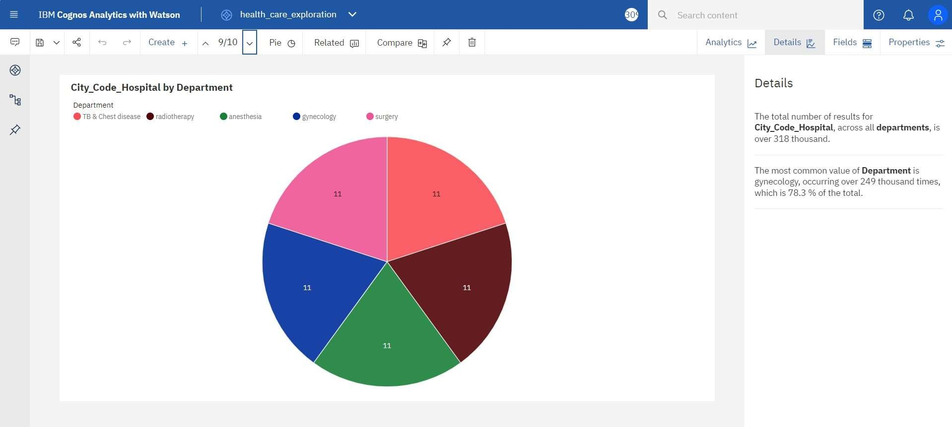

**DATA VISUALIZATIONS**

1. NUMBER OF PATIENTS BY WARD TYPE

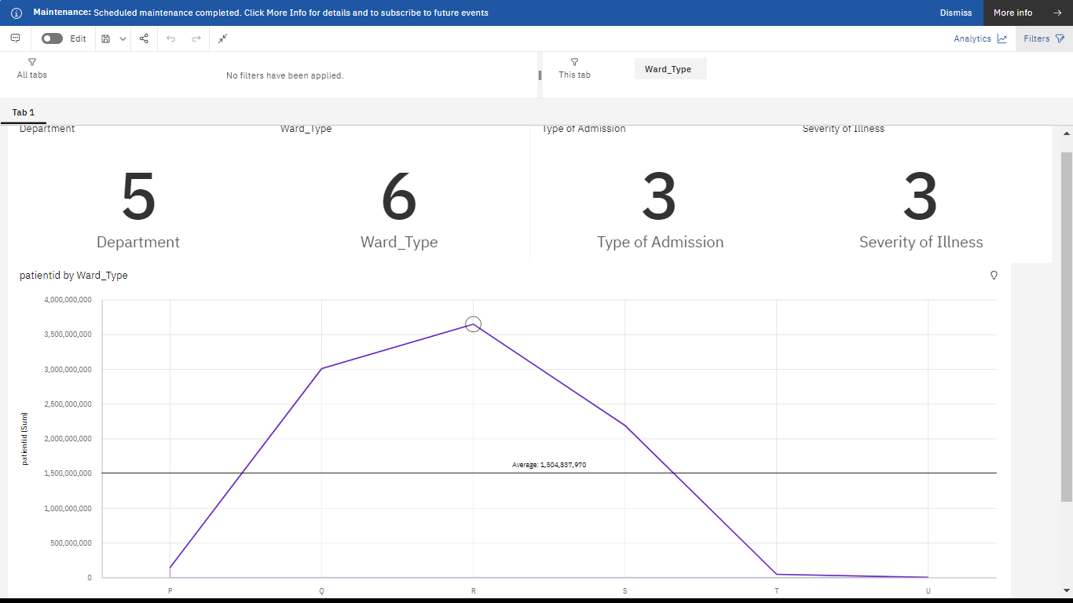

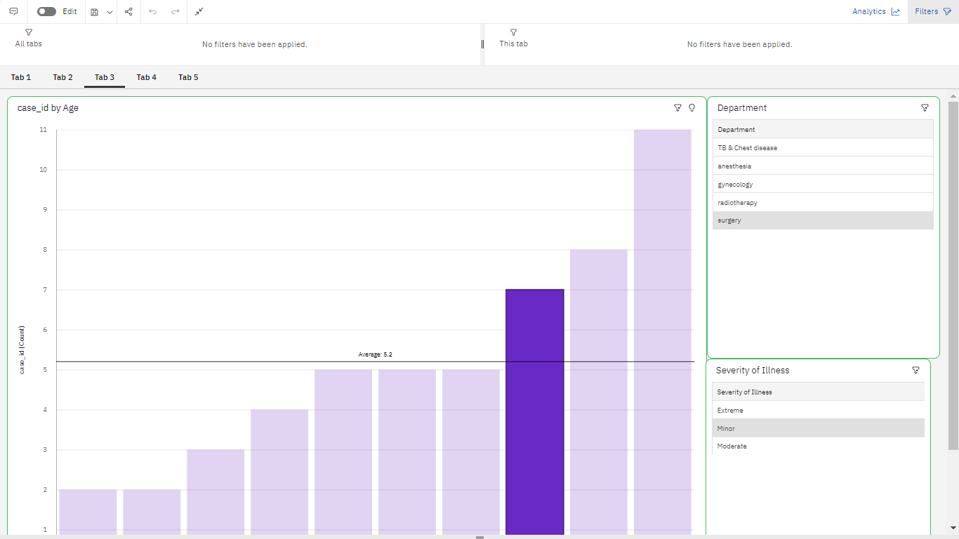AGE WISE PATIENTS WITH DEPARTMENT AND SEVERITY OF ILLNESS

STAY BY PATIENT ID

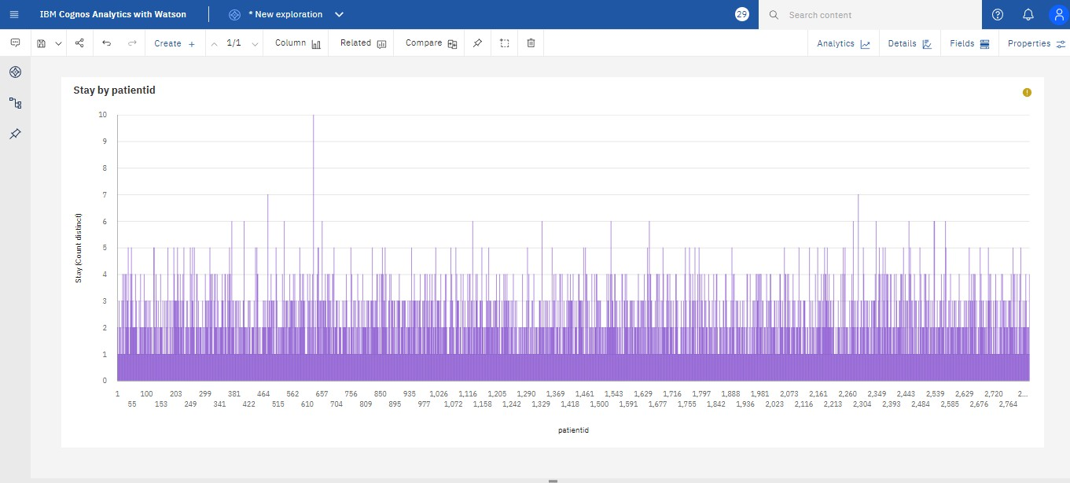

SEVERITY OF ILLNESS BY PATIENT-ID USING TREE MAP

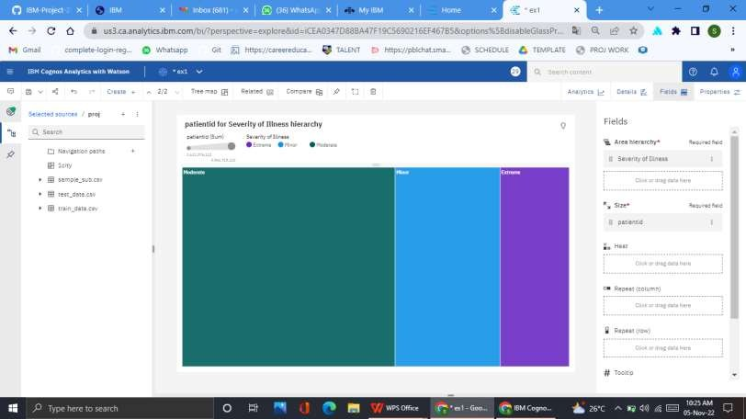

AGE AND DEPARTMENT WISE PATIENT USING TABLE

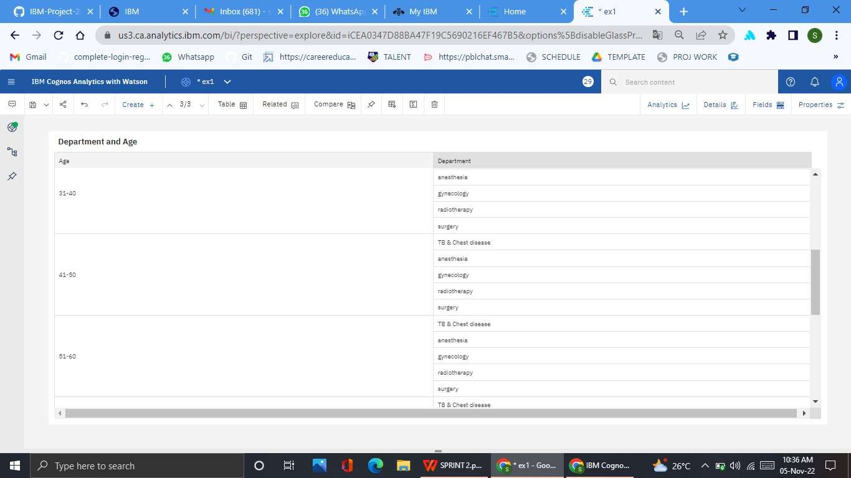

CASE ID BY AGE COLOURED BY DEPARTMENT

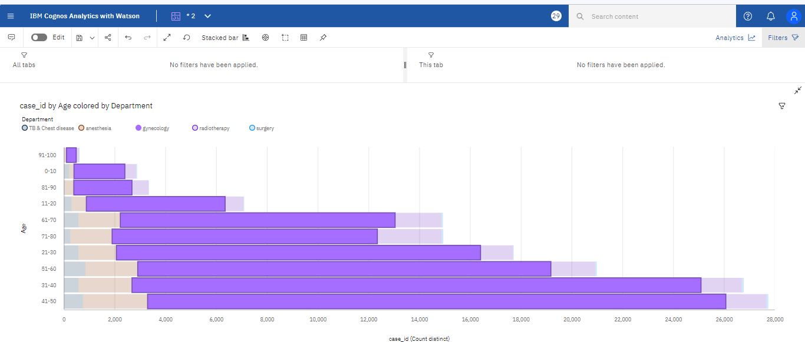

AVAILABILITY OF EXTRA BEDS IN HOSPITAL BY BED GRADE

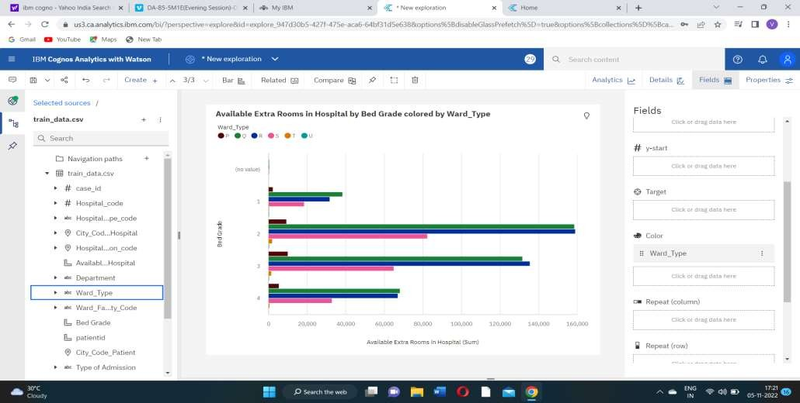

AGE AND DEPARTMENT WISE PATIENT USING TABLE



AVAILABILITY OF EXTRA ROOMS BY BED GRADE

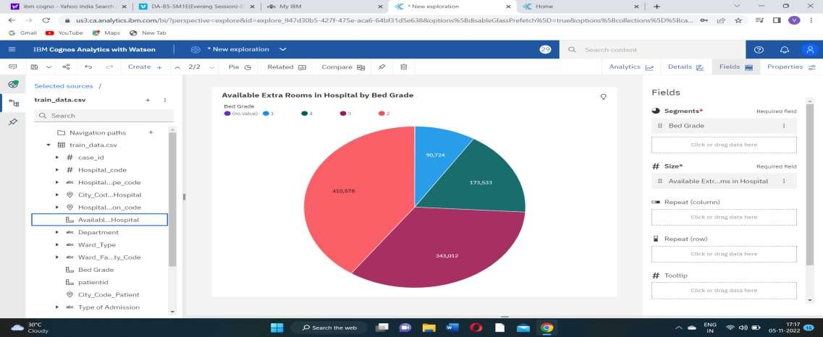

WARD TYPE FOR BED GRADE AND AVAILABLE EXTRA ROOMS

